# Section 5.1: Approximating Areas

## Sigma (Summation) Notation

One method to approximate area under the curve is to use shapes of known area (namely, rectangles). This process often requires adding up long strings of numbers. To make it easier to write down these lengthy sums, we look at some new notation.

**Sigma notation** (also known as **summation notation**) is presented in the form

$\sum_{i=1}^{n}{a_{i}}$

Where $a_{i}$ describes the terms to be added, and the $i$ is called the index. Each term is evaluated, then we sum all the vales, beginning with the value when $i=1$ and ending with the value when $i=n$.

Media: Watch this [video](https://youtu.be/A9xun5Le0uQ) example on summations in sigma notation.

Examples

1. Write in sigma notation and evaluate the sum of terms $3^{i}$ for $i=1, 2, 3, 4,5$.
2. Write the sum in sigma notation: $1+\frac{1}{4}+\frac{1}{9}+\frac{1}{16}+\frac{1}{25}$.

**Properties of Sigma Notation**

Let $a_{1},a_{2},…,a_{n}$ and $b_{1},b_{2},…,b_{n}$ represent two sequences of terms and let $c$ be a constant. The following properties hold for all positive integers $n$ and for integers $m$, with $1≤m≤n$.

$$\sum_{i=1}^{n}{c}=nc$$

$$\sum_{i=1}^{n}{ca_{i}}=c\sum_{i=1}^{n}{a_{i}}$$

$$\sum_{i=1}^{n}{(a_{i}+b_{i})}=\sum_{i=1}^{n}{a_{i}}+\sum_{i=1}^{n}{b_{i}}$$

$$\sum_{i=1}^{n}{(a_{i}-b_{i})}=\sum_{i=1}^{n}{a_{i}}-\sum_{i=1}^{n}{b_{i}}$$

$$\sum_{i=1}^{n}{a_{i}}=\sum_{i=1}^{m}{a_{i}}+\sum_{i=m+1}^{n}{a_{i}}$$

A few more formulas for frequently found functions simplify the summation process further. These are shown in the next rule, for sums and powers of integers.

**Sums and Powers of Integers**

1. The sum of $n$ integers is given by
$$\sum_{i=1}^{n}{i}=1+2+…+n=\frac{n(n+1)}{2}$$

2. The sum of consecutive integers squared is given by
$$\sum_{i=1}^{n}{i^{2}}=1^{2}+2^{2}+…+n^{2}=\frac{n(n+1)(2n+1)}{6}$$

3. The sum of consecutive integers cubed is given by

$$\sum_{i=1}^{n}{i^{3}}=1^{3}+2^{3}+…+n^{3}=\frac{n^{2}{\left(n+1\right)}^{2}}{4}$$

Media: Watch this [video](https://youtu.be/pehOZ-ItE6I) example on summation formulas.

Examples

1. Write using sigma notation and evaluate:
   1. The sum of the terms ${(i-3)}^{2}$ for $i=1, 2,…,200$.
   2. The sum of the terms $\left(i^{3}-i^{2}\right)$ for $i=1, 2, 3, 4, 5, 6$.
2. Find the sum of the values of $f\left(x\right)=x^{3}$ over the integers $1, 2, 3, …, 10$.

## Approximating Area

Let $f(x)$ be a continuous, nonnegative function defined on the closed interval $[a,b]$. The goal is to approximate the area $A$ bounded by $f(x)$ above, the $x$-axis below, and the line $x=a$ on the left, and the line $x=b$ on the right, as shown in the figure below.

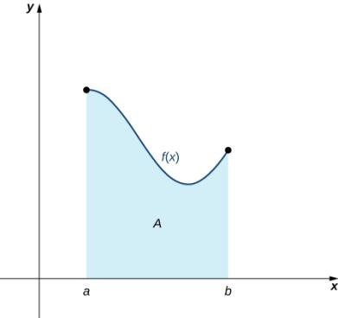

Using a geometric approach, divide the region into many small shapes that have known area formulas and then sum these areas to obtain a reasonable estimate of the true area. The first step is to divide the interval $[a,b]$ into $n$ subintervals of equal width, $\frac{b-a}{n}$.

A set of points $P=\left\{x_{i}\right\}$ for $i=0, 1, 2,…, n$ with $a=x_{0}<x_{1}<x_{2}<…<x_{n}=b$, which divides the interval $[a,b]$ into subintervals of the form $\left[x_{0},x_{1}\right], \left[x_{1},x_{2}\right],…,\left[x_{n-1},x_{n}\right]$ is called a **partition** of $[a,b]$. If the subintervals all have the same width, the set of points forms a **regular partition** of the interval $[a,b]$.

Use this regular partition as the basis of a method for estimating the area under the curve. Two methods used to estimate are: the left-endpoint approximation and the right-endpoint approximation.

**Left-Endpoint Approximation**

One each subinterval $[x_{i-1},x_{i}]$ (for $i=1, 2, 3, …, n$), construct a rectangle with width $∆x$ and height equal to $f(x_{i-1})∆x$. Adding the areas of all these rectangles, we get an approximate value for $A$ (as shown in the figure above). We use the notation $L_{n}$ to denote that this is a **left-endpoint approximation** of $A$ using $n$ subintervals.

$A≈L_{n}=f\left(x_{0}\right)∆x+f\left(x_{1}\right)∆x+…+f\left(x_{n-1}\right)∆x$

$=\sum_{i=1}^{n}{f\left(x_{i-1}\right)∆x}$

In the left-endpoint approximation of area under the curve, the height of each rectangle is determined by the function value at the left of each subinterval.

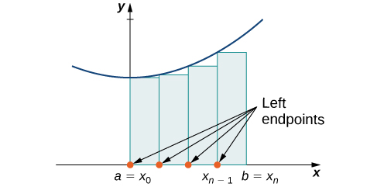

The second method for approximating area under a curve is the right-endpoint approximation. It is almost the same as the left-endpoint approximation, but now the heights of the rectangles are determined by the function values at the right of each subinterval.

**Right-Endpoint Approximation**

Construct a rectangle on each subinterval $[x_{i-1},x_{i}]$, only this time the height of the rectangle is determined by the function value $f(x_{i})$ at the right endpoint of the subinterval. Then the area of each rectangle is $f(x_{i})∆x$ and the approximation for $A$ is given by

$A≈R_{n}=f\left(x_{1}\right)∆x+f\left(x_{2}\right)∆x+…+f\left(x_{n}\right)∆x$

$=\sum_{i=1}^{n}{f\left(x_{i}\right)∆x}$

The notation $R_{n}$ indicates this is a **right-endpoint approximation** for $A$, shown in the figure below.

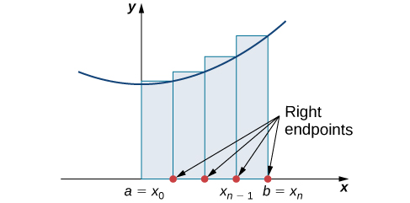

Depending on which method you choose, the approximation of the area could be an underestimate or an overestimate, as shown below. Figure (a) uses the left endpoints and figure (b) uses the right endpoints.

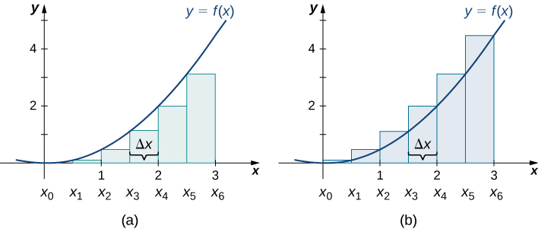

Using a small number of intervals does not give an accurate estimate of the area under the curve. However, as the number of points in the partition increases, the estimate of $A$ will improve. We will have more rectangles, but each rectangle will be thinner, so we will be able to fir the rectangles to the curve more precisely. See the two figures below.

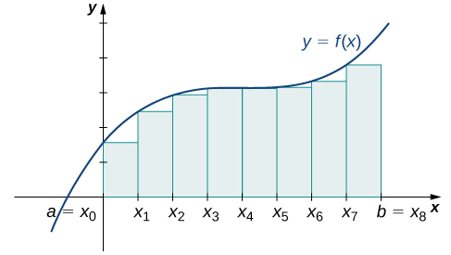 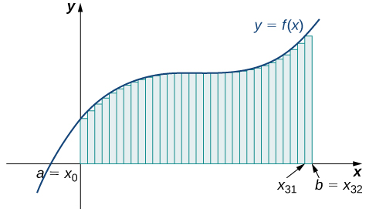

Media: Watch these [video](https://youtu.be/zwEoBhuyJq4)1 and [video2](https://youtu.be/eHbHQ2wqZvc) examples on approximating area with left and right endpoints.

Examples

1. Use both left-endpoint and right-endpoint approximations to approximate the area under the curve of $f\left(x\right)=x^{2}$ on the interval $[0,2]$; use $n=4$.
2. Estimate the area under the curve by computing the left Riemann sum, $L_{8}$.

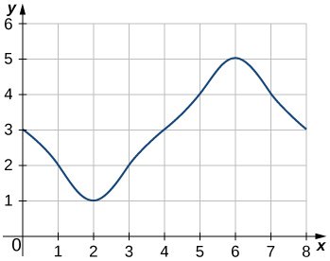

## Forming Riemann Sums

There is no reason to restrict evaluation of the function to one of the two endpoints only.

Let $f(x)$ be defined on a closed interval $[a,b]$ and let $P$ be a regular partition of $[a,b]$. Let $∆x$ be the width of each subinterval $[x_{i-1},x_{i}]$ and for each $i$, let $x_{i}^{*}$ be any point in $[x_{i-1},x_{i}]$. A **Riemann sum** is defined for $f(x)$ as

$\sum_{i=1}^{n}{f(x_{i}^{*})}∆x$

Recall that with the left- and right-endpoint approximations, the estimates seem to get better and better as $n$ gets larger and larger. The same thing happens with Riemann sums. Riemann sums give better approximations for larger values of $n$.

Let $f(x)$ be a continuous, nonnegative function on an interval $[a,b]$, and let $\sum_{i=1}^{n}{f(x_{i}^{*})}∆x$ be a Riemann sum for $f(x)$. Then, the **area under the curve $y=f(x)$** on $[a,b]$ is given by

$A=\lim_{n→∞}{\sum_{i=1}^{n}{f(x_{i}^{*})}∆x}$

Although any choice for $\left\{x_{i}^{*}\right\}$ gives us an estimate of the area under the curve, we don’t necessarily know whether that estimate is too high (overestimate) or too low (underestimate). We can select our value for $\left\{x_{i}^{*}\right\}$ to guarantee one result over another.

If we want an overestimate, we can choose $\left\{x_{i}^{*}\right\}$ such that for $i=1, 2, 3, …, n, f(x_{i}^{*})≥f(x)$ for all $x∈[x_{i-1},x_{i}]$. If we select $\left\{x_{i}^{*}\right\}$ in this way, then the Riemann sum is called an **upper sum**.

If we want an underestimate, we can choose $\left\{x_{i}^{*}\right\}$ such that for $i=1, 2, 3, …, n, f(x_{i}^{*})$ is the minimum function value on the interval $[x_{i-1},x_{i}]$. In this case, the the Riemann sum is called a **lower sum**.

Media: Watch this [video](https://youtu.be/MiwUXZUsLok) example on Reimann sum with a graph.

Media: Watch these [video1](https://youtu.be/RoSx4lF1XCk) and [video 2](https://youtu.be/XK3fM2sK99k) examples on Reimann sums with different functions.

Example: Find a lower sum for $f\left(x\right)=10-x^{2}$ on $[1,2]$; let $n=4$ subintervals.